Project Design Phase-II
Data Flow Diagram & User Stories

Date | 25 September 2026
Team ID | SWTID-2026-9989
Project Name | Script-Controlled ACL – Restrict Record Access Based on Field Value
Maximum Marks | 4 Marks

Data Flow Diagrams:
A Data Flow Diagram (DFD) is a traditional visual representation of the information flows within a system. A neat and clear DFD can depict the right amount of the system requirement graphically. It shows how data enters and leaves the system, what changes the information, and where data is stored.
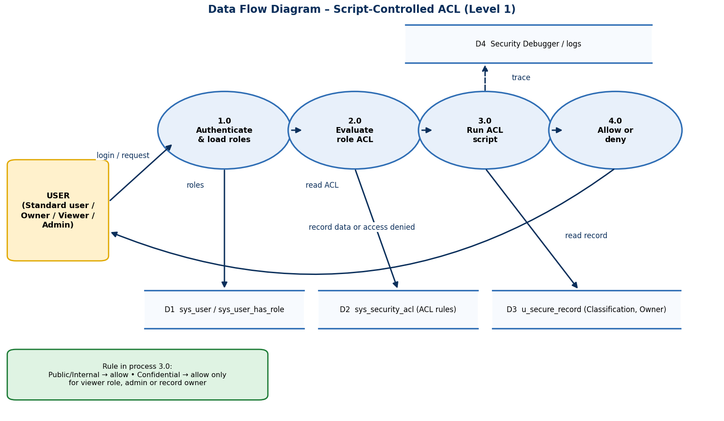
Flow: the user's request is authenticated (1.0), checked against role ACLs (2.0), then the ACL script (3.0) reads the record's Classification and the user's roles/ownership before the platform returns the record or denies access (4.0).

User Stories
Use the below template to list all the user stories for the product.
User Type | Functional Requirement (Epic) | User Story Number | User Story / Task | Acceptance criteria | Priority | Release
Administrator | Table Setup | USN-1 | As an administrator, I can create the Secure Records table with Title, Description and Owner fields so that records can be stored. | Table u_secure_record is visible in the application navigator | High | Sprint-1
Administrator | Table Setup | USN-2 | As an administrator, I can add a Classification field (Public / Internal / Confidential) so that access can depend on its value. | Classification appears on form and list with three choices | High | Sprint-1
Administrator | Role & User Management | USN-3 | As an administrator, I can create the role u_confidential_viewer so that authorised people can be identified. | Role exists in the Roles table | High | Sprint-1
Administrator | Role & User Management | USN-4 | As an administrator, I can create test users and assign roles so that every scenario can be tested. | Users exist with the expected roles | Medium | Sprint-1
Record Owner | Record Entry | USN-5 | As a record owner, I can create records and set their Classification so that sensitive data is labelled. | Sample Public, Internal and Confidential records are saved | High | Sprint-1
Administrator | Script-Controlled ACL | USN-6 | As an administrator, I can create a read ACL with a script so that visibility depends on the Classification value. | Read ACL is active and script saves without errors | High | Sprint-2
Administrator | Script-Controlled ACL | USN-7 | As an administrator, I can create write and create ACLs with the same rule so that Confidential records cannot be edited by others. | Unauthorised update is blocked | High | Sprint-2
Administrator | Script-Controlled ACL | USN-8 | As an administrator, I can restrict delete to the admin role so that records are not removed accidentally. | Non-admin delete is denied | Medium | Sprint-2
Administrator | Script-Controlled ACL | USN-9 | As an administrator, I can use Security Debugger so that I can see why access was allowed or denied. | Debugger shows ACL result for each record | Medium | Sprint-2
Confidential Viewer | Access Scenarios | USN-10 | As a confidential viewer, I can open Confidential records so that I can do my review work. | All records appear in the list and open on the form | High | Sprint-3
Record Owner | Access Scenarios | USN-11 | As a record owner, I can always open my own Confidential records even without the viewer role. | Owner sees own record only | High | Sprint-3
Standard User | Access Scenarios | USN-12 | As a standard user, I see only Public and Internal records in the list so that sensitive data stays hidden. | Confidential rows are not listed | High | Sprint-3
Standard User | Access Scenarios | USN-13 | As a standard user, I am denied when I open a Confidential record by its direct link. | Access-denied message; no field data shown | High | Sprint-3
Administrator | Verification | USN-14 | As an administrator, I can change a record's Classification and see visibility update immediately. | Visibility changes on next list refresh | Medium | Sprint-3
Administrator | Testing & Release | USN-15 | As an administrator, I can run UAT and log results so that the solution is accepted. | UAT sheet completed and signed off | Medium | Sprint-4
Administrator | Testing & Release | USN-16 | As an administrator, I can export an Update Set and push the scripts to GitHub so that the work is backed up. | Update Set exported; repository updated | Medium | Sprint-4
Project Team | Documentation | USN-17 | As a team, we can complete the project report and demo so that the project can be submitted. | Report and demo ready | Medium | Sprint-4

